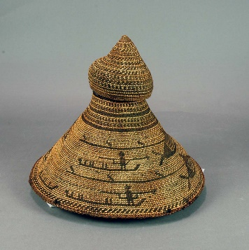
Packing Instructions: Nootka Sound Hat (A.1956.658) & Knife (A.1956.1019)
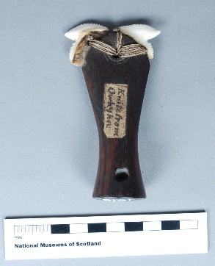
A.1956.1019
Knife (Hawaii)
A.1956.658
Nootka Sound Hat

Unpacking of Hat and Knife
- Bring front side down before carefully removing both Tyvek-cushions.
- Pull out front half of cut out for hat (see red arrow) in order to be able to slide the hat forward
on its mount.
- The hat should be lifted out of the box on its mount and it is not recommended that it be removed from its mount at any time.
- (The side of the hat which is facing the person at this point has been chosen as the display view for the exhibition.)
- To get access to the knife it is necessary first to remove the hat from the box.
- Remove tray which lay under hat (Plastazote/Correx-sandwich) and next layer to get access to the knife recess at the bottom of the box.
- Remove small lid from knife and lift out knife.

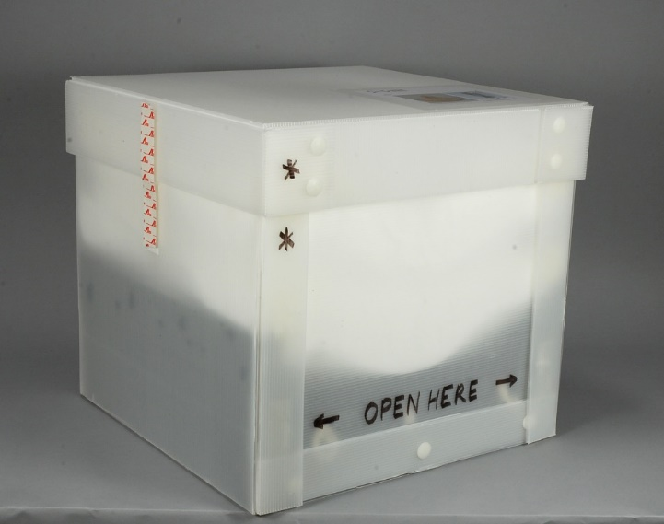
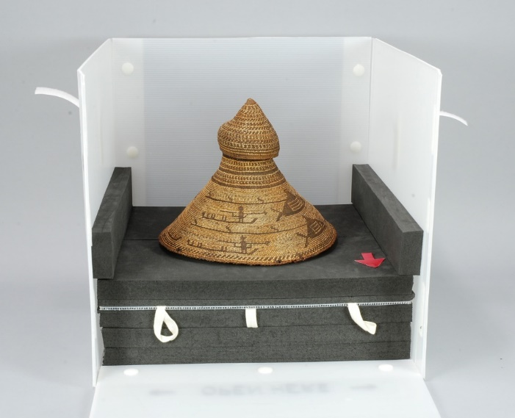
4.
1.

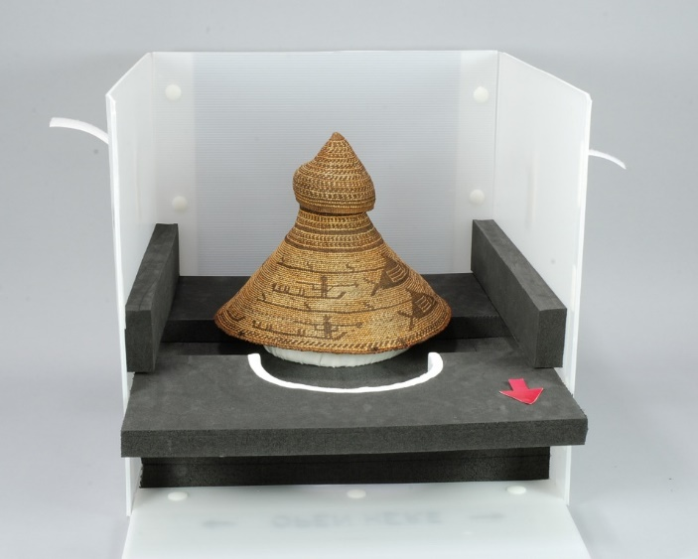
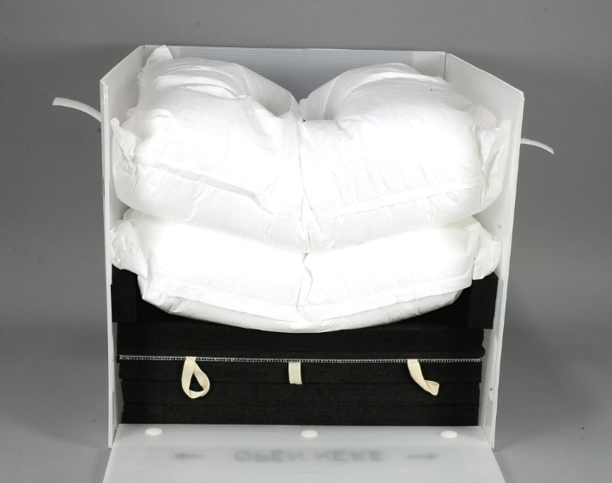
5.
2.

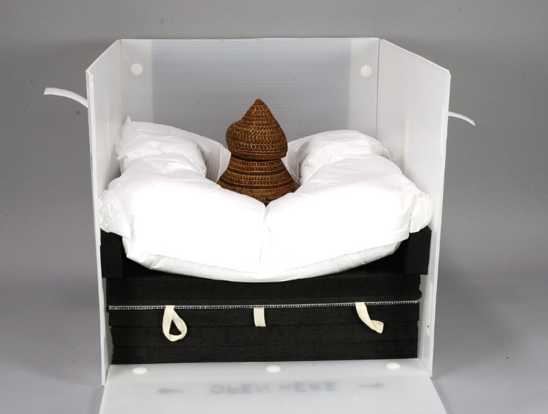
3.
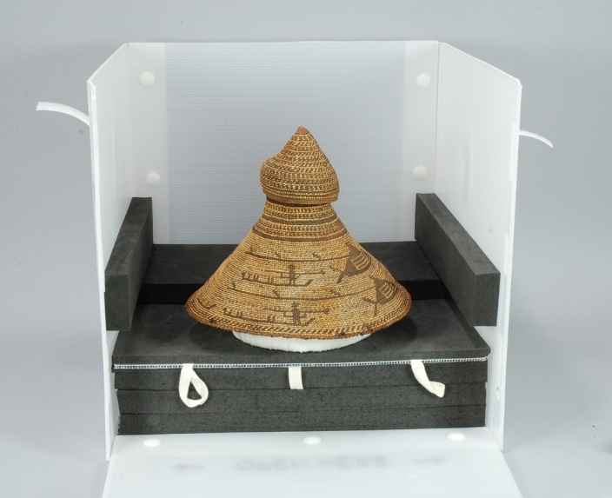
6.

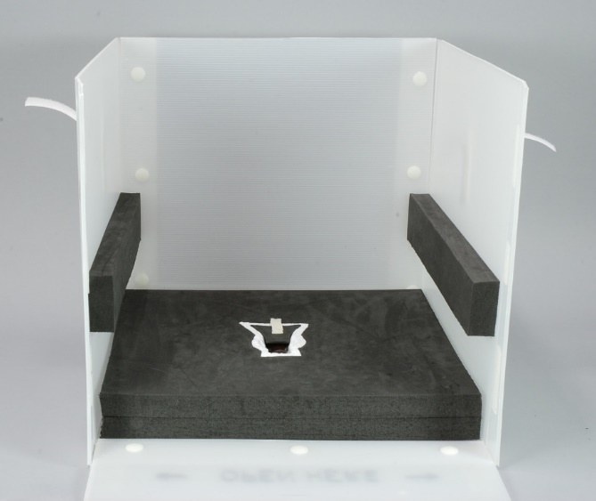
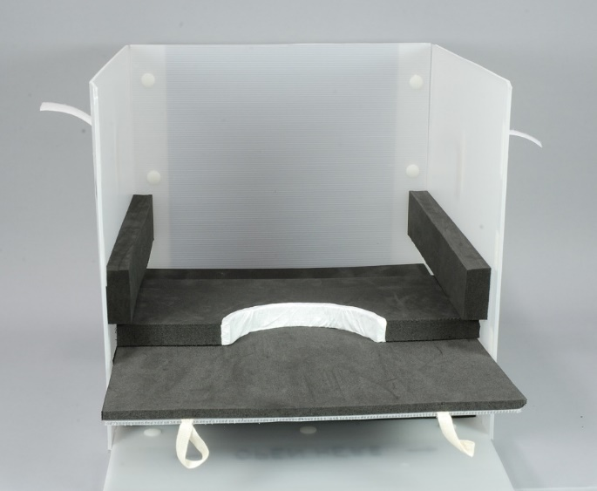
9.
7.

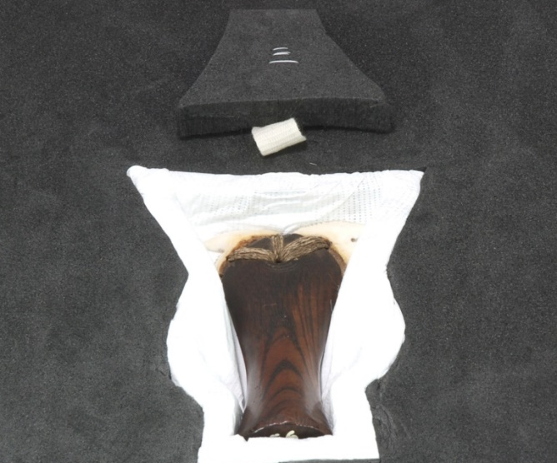
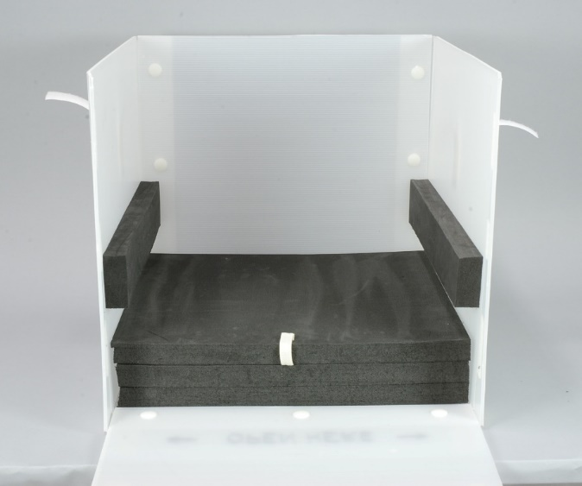
10.
8.

Repacking of Hat and Knife
(Follow images in reverse order)
- Place knife in its cut out and cover with small lid.
- Cover knife with square foam sheet.
- Slide tray (Plastazote/Correx-sandwich) of hat back in. Tray has to sit directly on the foam cover of knife (i.e. not on top of the two foam bars attached to the sides of the box).
- (Place hat on its mount back onto the tray. Ensure that the chosen part of the depiction is facing the open side of the box.)
- Slide in first half of the cut out for the hat.
- Carefully place Tyvek-cushion with large hole around the hat.
- Close front flap of the box and ensure that Dual Lock tape is interhooked properly, e.g. by supplying pressure from the inside of the box as well as outside.
- Carefully place second cushion with smaller hole on top of first cushion.
- Replace lid of box and attach Velcro-strips on either side.

