METHOD STATEMENT: Boxed Textiles
Metal fasteners or buttons on textiles should be covered with acid-free tissue so as to minimise abrasion against the textile from possible corrosive surfaces.
What you will need:
Nitrile gloves
Acid-free textile box
Acid-free tissue

Method:
- Inventory the object/s. Always use pencil around textiles.
- Ensure you have a big enough workspace to pack the object.
- Select a container large enough to fit the textile with minimal or no folding.
- Line the container with acid-free tissue. Place multiple sheets in the base and over the side and end panels of the container.
If possible cut a piece of tissue large enough to cover the base of the container and fold back over the textile. This will aid in lifting the textile in and out of the container in the future.
- Ggently place the textile into the box. If the textile is large or awkward in shape ask for handling assistance. Support smaller textiles when possible using an acid-free board as a support.
- Make sure the textile is laying flat. Some items will have natural folds (e.g. pleats or gathers, which should be supported in place with acid-free tissue sausages. Some items need to be folded gently, bearing in mind their structure, to get in the box, and those folds must not be creased and should be supported with pads and sausages.
- If possible, do not place textiles on top of one another. Accumulated weight may crush items. If layering cannot be avoided, place heavier items on the bottom and lighter items towards the top. Additionally, if the items have labels sewn in place with their accession numbers, layer them in the container if possible so as their numbers are positioned to one side of the box. This will aid in easy accessibility and identification of items in the future.
- If layering, separate each textile layer with several sheets of acid-free tissue.
- Once packed, fold over the tissue sheets from around the side panels of the container.

Image 1. Use acid-free tissue sausages to support folds in flat textiles. Interleave with layers of acid-free tissue to prevent abrasion between textile layers.
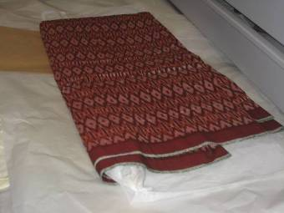
Image 2. Flat textile with fold supported with acid-free tissue sausage. Tissue will prevent damaging creases from forming.
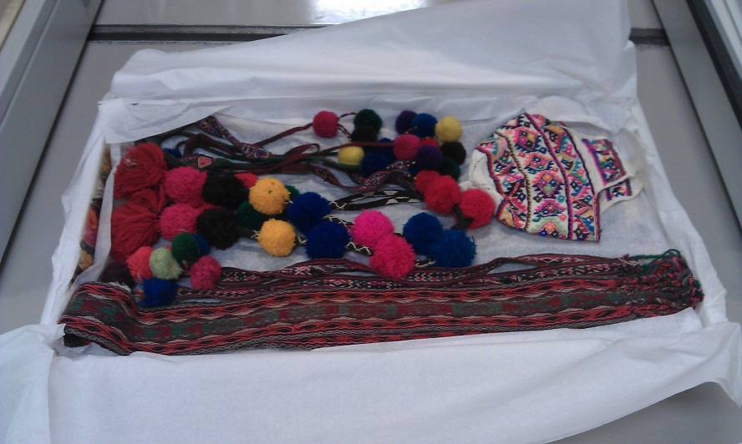
Image 3. Bread tray lined with acid-free tissue holding multiple layers of flat textile items. Note error in packing with heavier bulky items on top layer.

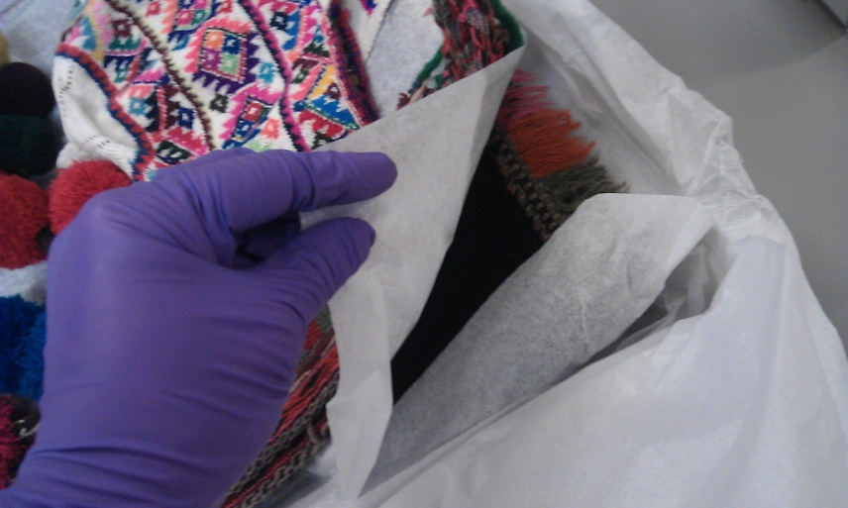
Image 4. Multiple layers separated by acid-free tissue.

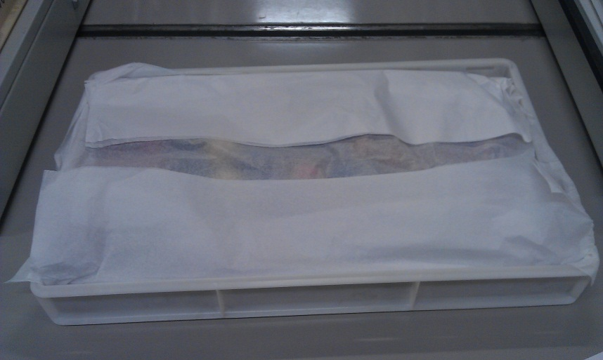
Image 5. Finish by folding over top layers of acid-free tissue to completely enclose items.

