PACKING METHOD STATEMENTS
METHOD STATEMENT: Paper artefacts in Melinex sleeves or Acid-free tissue layers
If in any doubt how to handle or pack a paper artefact please consult a Paper Conservator before starting work.

What you will need:
Nitrile gloves
Tray or container
Plastazote liner & blocks
Melinex sleeves or Acid-free tissue
Method:
- Inventory all objects. Use pencil when working with paper artefacts in case of accidental marking.
- Find a container of suitable height dependent on the size of items to pack.
- Place a plastazote tray liner in the base of the container.
- Cut Melinex sleeves to desired size dependent on object to pack.
- Wearing gloves handle one object at a time. Place each item into an individual Melinex sleeve or in an acid-free tissue layer dependent on the item to pack.
- Label each sleeve with the accession number of the object.
- Place each sleeve in to the tray. Placing one on top of the other. Ensure accession numbers are all positioned in the same place on the Melinex sleeves to enable easy access to objects in the future (Image 1).
If not using sleeves place one item at a time into the tray adding an acid-free tissue layer between every item. Place a Tyvek label with the accession number next to the object in each layer. If packing multiple layers place heavier and/or larger items on the base layer and lighter items on top.
- If packing 3-D paper objects wrap each object individually in acid-free tissue. Place objects in to a tray and pin with plastazote blocks to support if required (Image 2.).
- Place a tyvek label with the accession number next to the object.
- Once packed, place two sheets of acid-free tissue over the objects to protect from dust and debris.
Packing Tip
Paper artefacts in Melinex sleeves or folded in acid-free tissue can be secured in bread trays by using plastazote pinning outlined in Method 1. Cotton tape can be used to secure the sleeves in place to prevent them from sliding in the container during transit and movement in storage (Image 3).
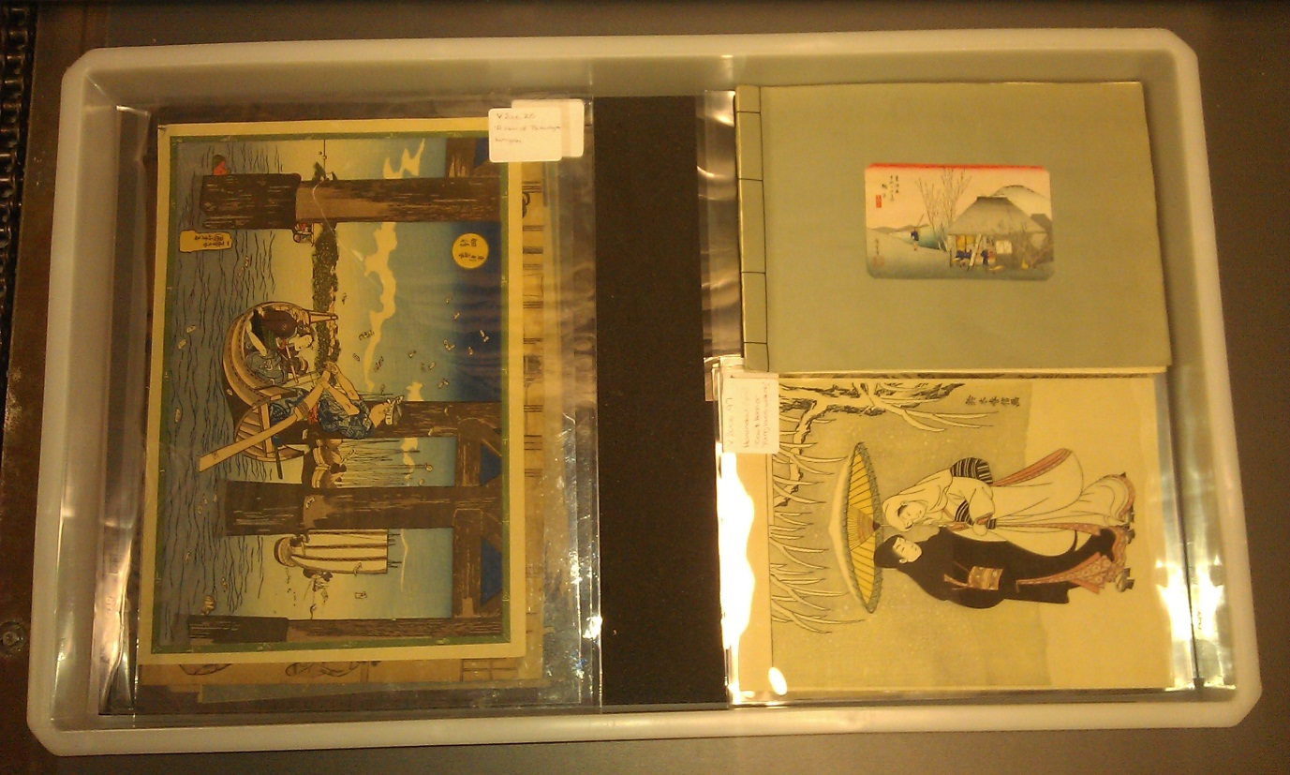
Image 1. Japanese paper prints placed in individual Melinex sleeves. Sleeves can be placed on top of each other without acid-free layers in between. Sticky labels can be placed on the outside of Melinex sleeves with accession number and object name.

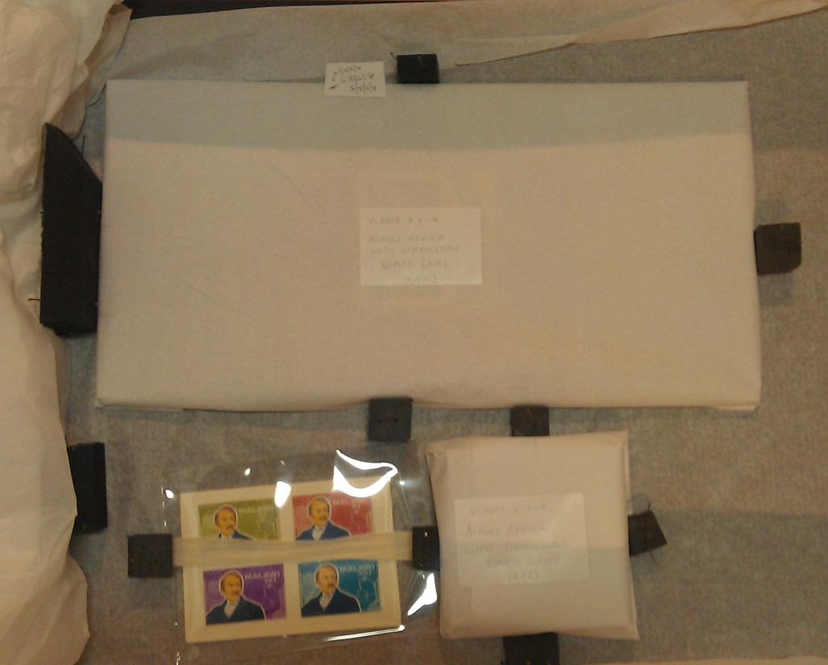
Image 2. Paper artefacts wrapped in acid-free tissue and secured with plastazote blocks. Outside of tissue labelled in pencil with accession number and object name.

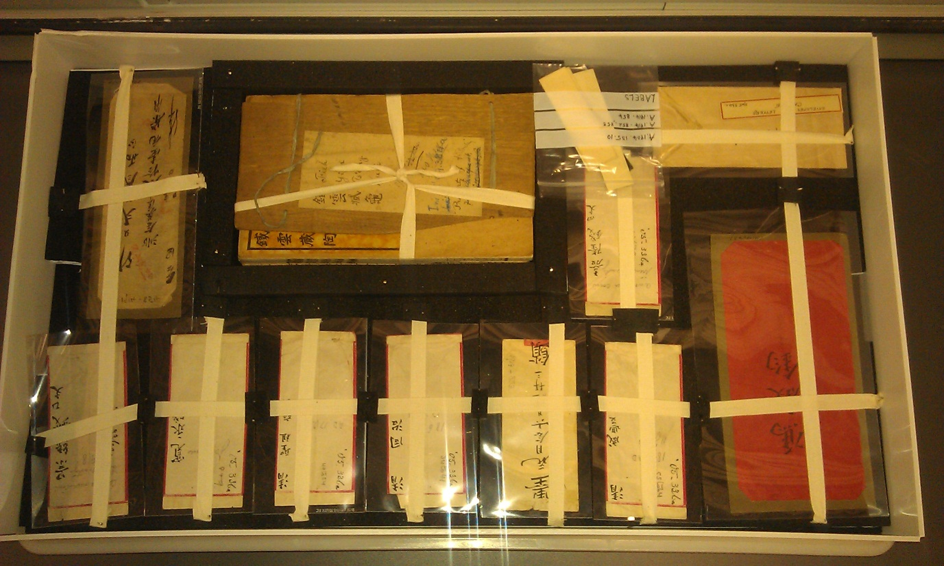

Image 3. Paper artefacts placed in Melinex sleeves and held in place with cotton tape pinned by plastazote blocks. Heavier paper items of larger depth (see middle top) blocked in around the perimeter with long strips of pinned plastazote.

