METHOD STATMENT: Plastazote Pinning
What you will need:
Nitrile gloves
Rigid container
Correx sheet
Plastazote Tray liner - 3mm
Stanley knife
Metal ruler
Cutting matt
Plastazote blocks
Stainless steel pins

Method

- Select a bread tray of suitable height dependent on the height of objects to pack.
- Using a stanley knife and cutting matt cut a correx sheet to fit the base of the container.
- Cut 3mm plastazote liner to size and place on top of the correx layer.
- Move one object into the tray at a time.

When placing objects into trays try to:
- Position the objects in the tray on their most stable side.
- Try to position objects so accession numbers if present are visible therefore to avoid excess handling of the object in the future. All objects coming off display should have been given a Tyvek label with their accession number. Place, tie with cotton tape or pin this label next to the object.
- Position objects to distribute weight evenly across the tray.
- Position objects of similar material and substance together when possible (e.g. Do not place heavy items next to fragile delicate items).
- Do not overpack objects into trays. Ensure accessibility of objects when packed.

- Once all objects to pin are in place cut out plastazote blocks of various sizes.
- Place cut blocks carefully around the outside edge or underneath the object to provide support. Make sure the edge the plastazote is against is stable and robust enough to withstand contact. Do not place blocks against fragile, friable, delicate or protruding surfaces.
- Place a pin through the plastazote and push through into the correx layer. Push the pins in at an angle instead of vertically to avoid pins dislodging during movement. Use 2 or multiple pins per block as required.
- Once all objects are pinned assess the objects to ensure all are stable and labelled.
- Place any essential information about the tray contents on the outside of the tray (e.g. fragile objects, the weight of the tray if excessive, uneven weight distribution, hazardous objects contained, toxic substances present). If objects are protruding above the top of the container, ensure this is made clear with a warning.

Packing Tips

Some objects may benefit from additional support in the tray other than with blocks. Objects can be supported using thin plastazote strips (Image 4) or cotton tape (Image 5) that can be pinned over the object. Additionally, using tissue puffs to provide a cushion may be advantageous for delicate items where a plastazote block may put too much pressure on an item (Image 6). Blocks can then be pinned around the tissue cushion to prevent the object sliding.

For small, particularly fragile objects where pinning directly against the edges would not be ideal polythene bags can be used to place the object inside and the bag then pinned in place (Image 7 & 8).

Image 1. Plastazote blocks pinned around edges of metal objects to prevent movement.
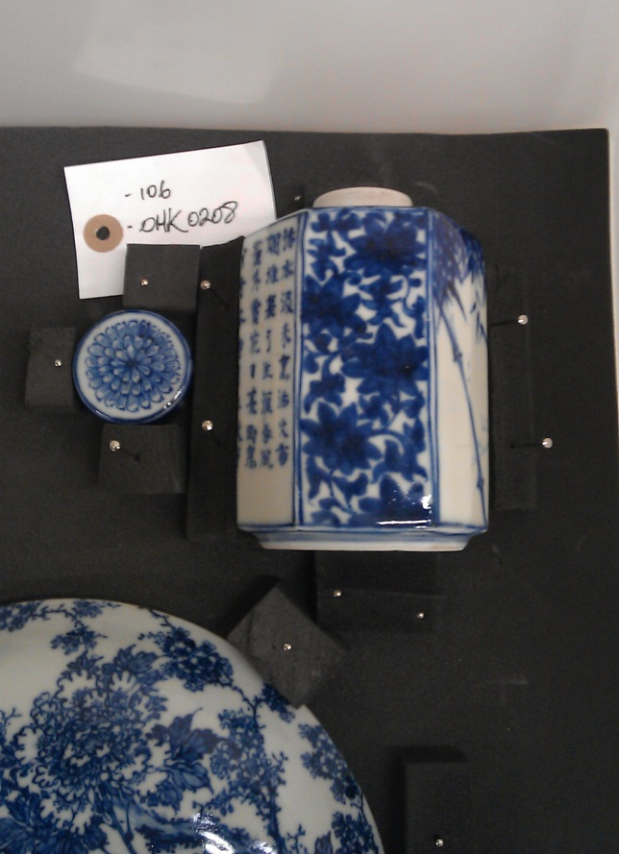
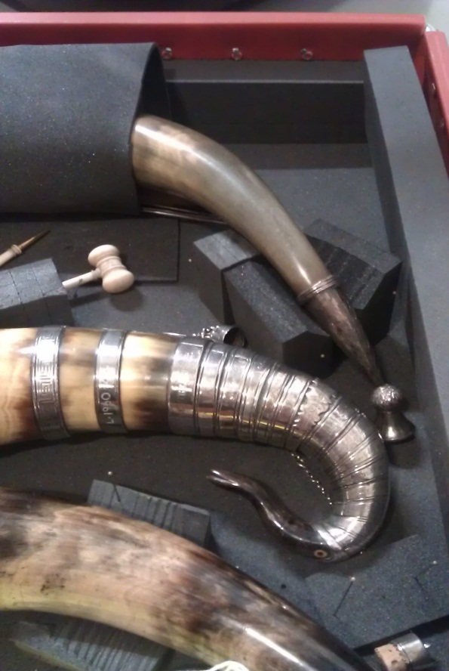
Image 3. Objects cradled underneath with custom cut plastazote blocks.
Image 2. Check objects with detachable parts and pack separately.

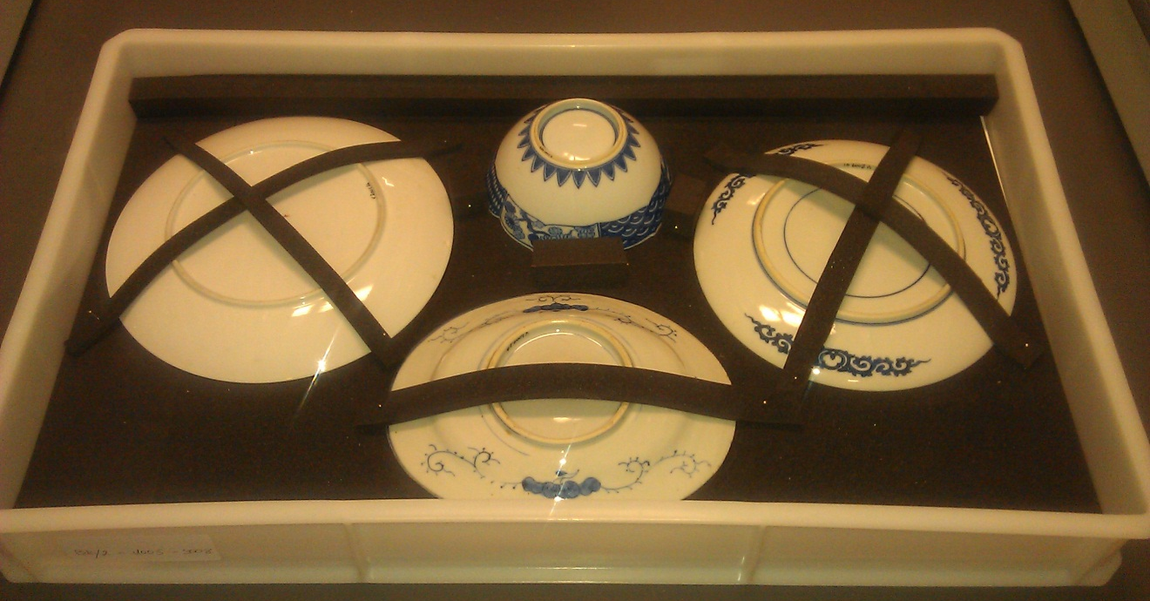
Image 4. Plastazote strips pinned over objects to prevent objects lifting during movement.

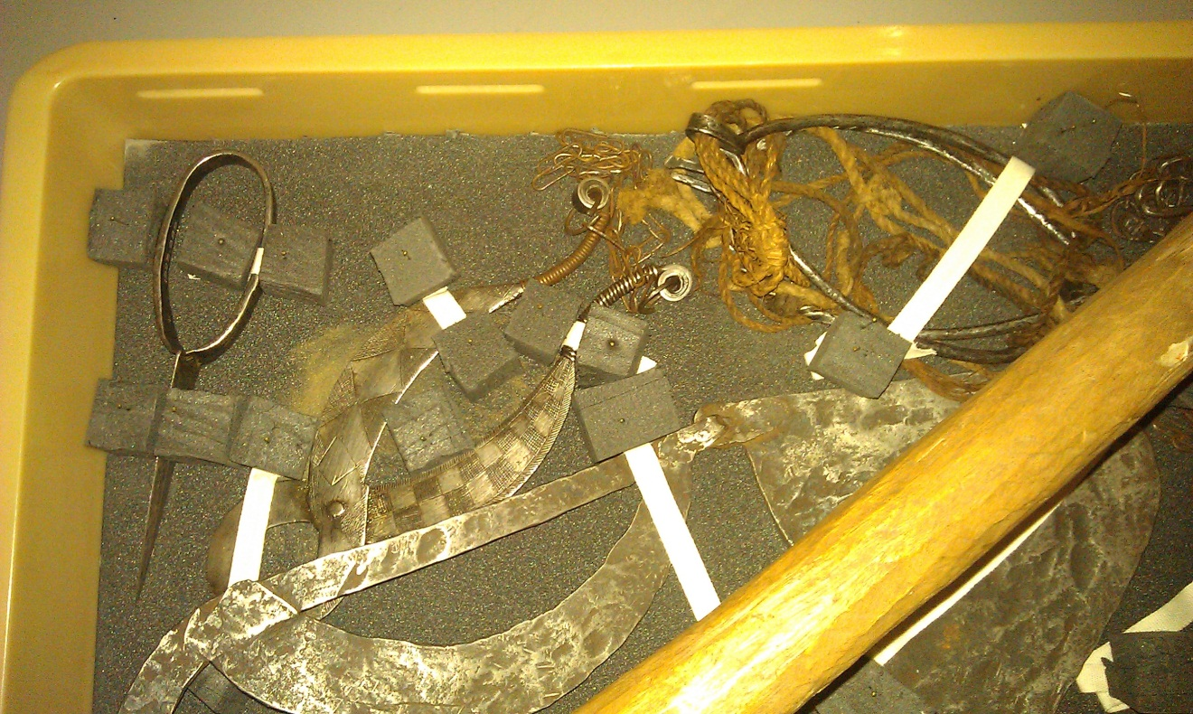
Image 5. Cotton tape pinned over objects and secured with plastazote blocks to prevent lifting during movement.

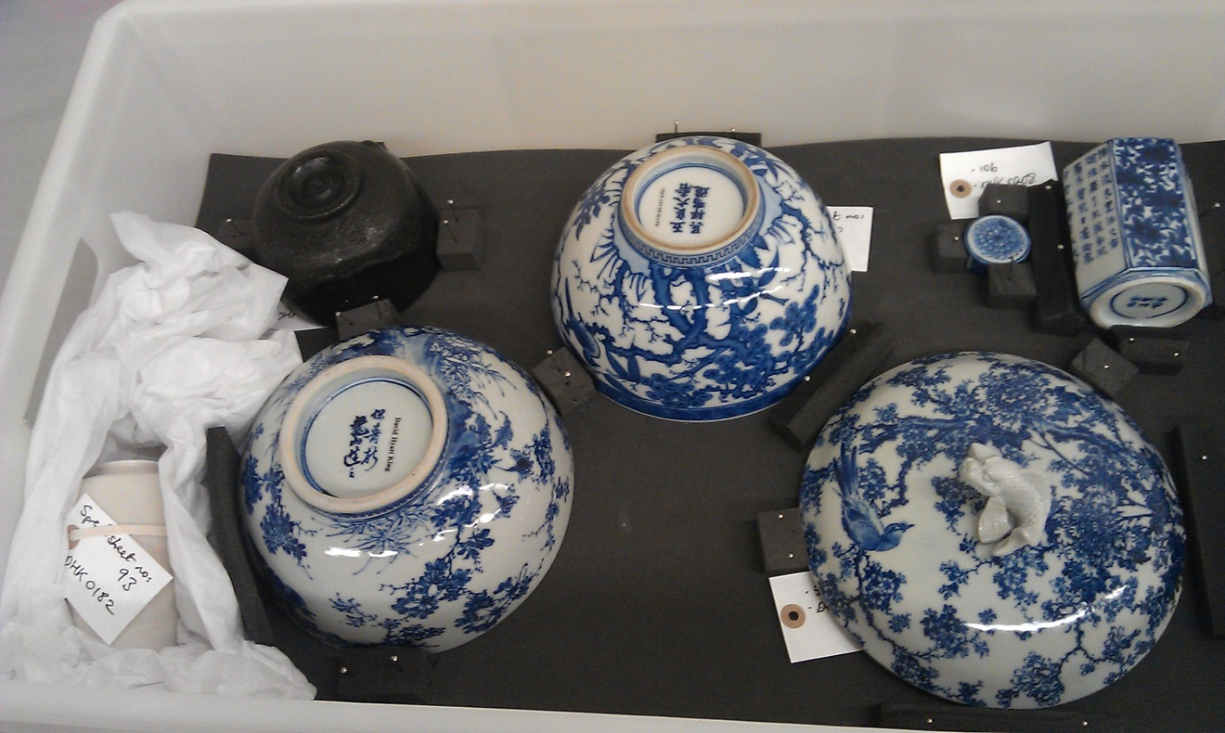
Image 6. Object placed on acid-free tissue nests for cushioning in conjunction with pinned plastazote blocks.
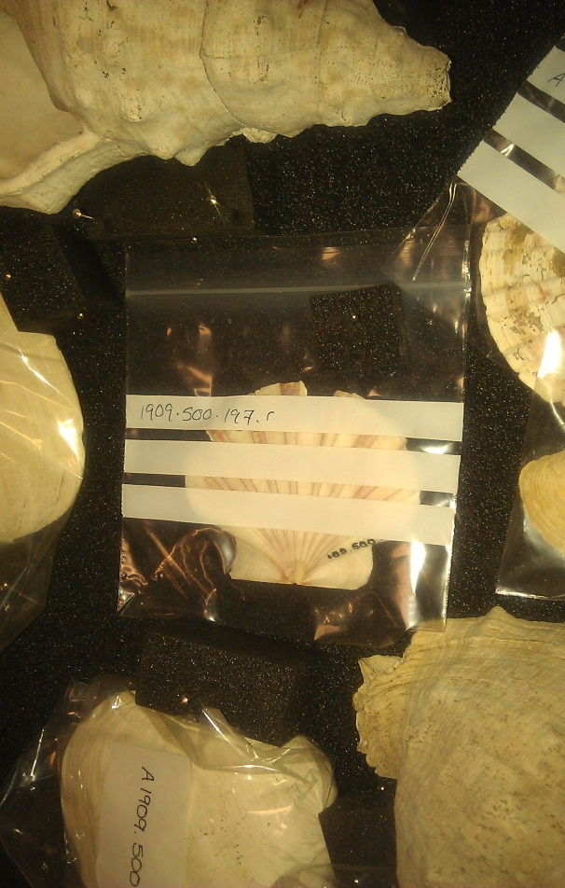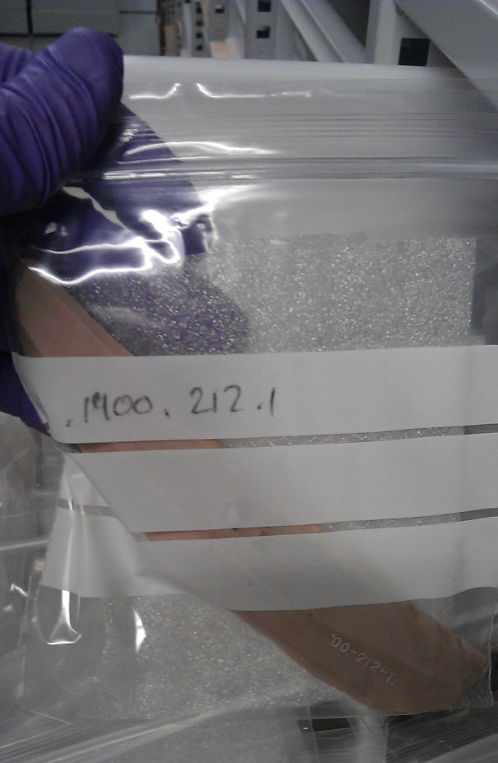
Image 7 & 8. Fragile delicate objects (L-R: Shell and Flint fragment) packed in zip-lock bags and pinned in place. Accession numbers can be written on the outside of the bag.

