METHOD STATEMENT: Soft-wrapping
Suitable for: Oversize robust objects with stable surfaces that do not fit in conventional packing containers e.g. furniture, framed art, large metal, wooden or stone sculpture.

Softwrapping artefacts

What you will need:
Nitrile gloves
Polythene sheet
Jiffy foam
Acid-free tissue
Scissors
Tape

Method:

- Assess object to determine size of wrap needed.
- Is the object heavy and robust then use thick jiffy foam.
- Is the object medium lightweight then use thin jiffy.
- Cut jiffy foam to required size and lay out a double layer on a padded surface. (If using bubble wrap instead, make sure the bubbles are facing away from the object when wrapping to avoid the wrap leaving impressions if coming into contact with the object surface.)
- Place sheets of acid free tissue on top of the jiffy.
- Wearing gloves, move the object on to the centre of the jiffy and tissue.
- Wrap the object carefully in the tissue tucking the tissue around the object. Do not tape the tissue in place.
- Wrap the object then in the jiffy and secure with tape.
- If the object is travelling through a non-controlled environment (eg outside), wrap the object in a final layer of polythene.
- Label the front of the object with any relevant object details i.e. object orientation, weight if excessive, lifting instructions.
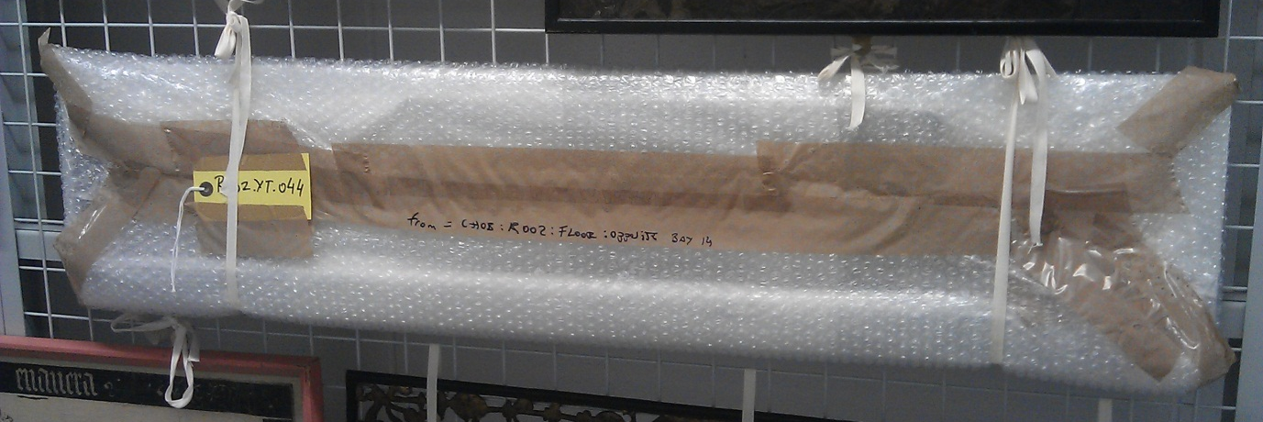

Image 1. Softwrapped oversized panel. Note acid-free tissue layer inside and bubble facing outwards.

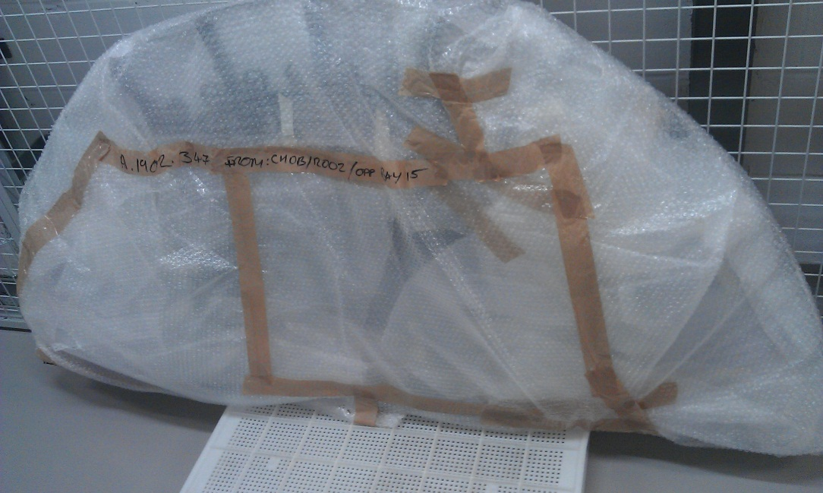

Image 2. Softwrapped oversized metalwork wrapped in multiple bubble layers.

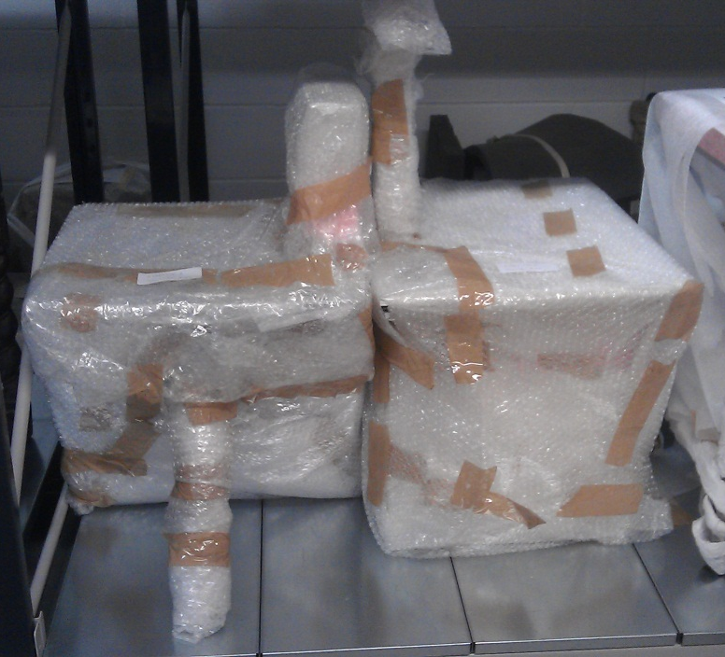

Image 3. Softwrapped furniture items.

Softwrapping Framed items

Be aware of glass in framed objects. Is the glass historical, safety glass of Perspex?
Do not tape perspex or safety glass. Additionally, be careful of hooks and fixtures on the backs of frames as these can catch on or scratch items. Cover and label if required.

What you will need:

Nitrile gloves
Jiffy foam
Polyethylene wrap
Acid-free tissue
Cotton tape
Adhesive tape
Glass tape

Method:

- Assess the object. Do I need another object handler to assist? Is it glazed or unglazed?
- If glazed, wearing gloves use glass tape and tape in the direction of the widest part of the glass.
- If unglazed, using cotton tape, stretch the tape across the front of the frame from side to side. Place acid-free tissue in between where the tape and frame are in contact. Secure cotton tape at the back of the frame in a tight bow. Do the same again but on the vertical plane.
- Cut sections of jiffy foam and fold to produce padded corners large enough to cover the frame corners. Place foam on one corner at a time and secure with masking tape to hold the foam shape.
- Cut a sheet of polyethylene and wrap the object. The cotton tape across the front of the frame will prevent the polyethylene from coming into contact with the art work.
- Make sure the object is air tight. Secure the plastic folds with tape on the back of the object so as not to hide the art work if taped from the front.
- Stand large framed work on foam blocks at an angle against a stable solid surface.
- Label the object with details as required.

If the object has a shallow frame the object does not require jiffy padded corners. The object can be wrapped in several layers of jiffy foam entirely and sealed with a layer of polyethylene wrap and parcel tape.

When storing or transporting framed objects always place frames face to face or back to back. This is to avoid backing fixtures and protruding parts laying against the flat art sides of objects which could damage the art face or glazed front.
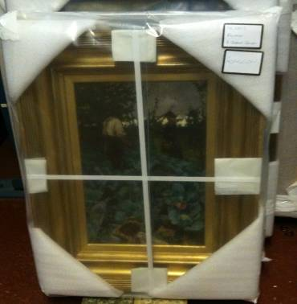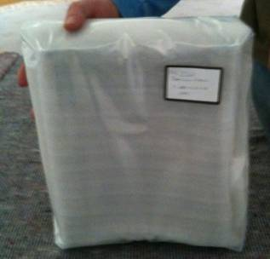
Image 5. Softwrap shallow frames with internal jiffy foam and outer polyethylene wrap.
Image 4. Softwrap large frames with jiffy foam corners and polyethylene wrap.

