Crate number: | M23
Pod number: | 5 – Gum, Invertebrates and Tools
Contents: | MB45 Brown capuchin + cashew nuts  MB46 Chimpanzee  MB47 Chimpanzee tools x8
Notes:
Photo of crate interior
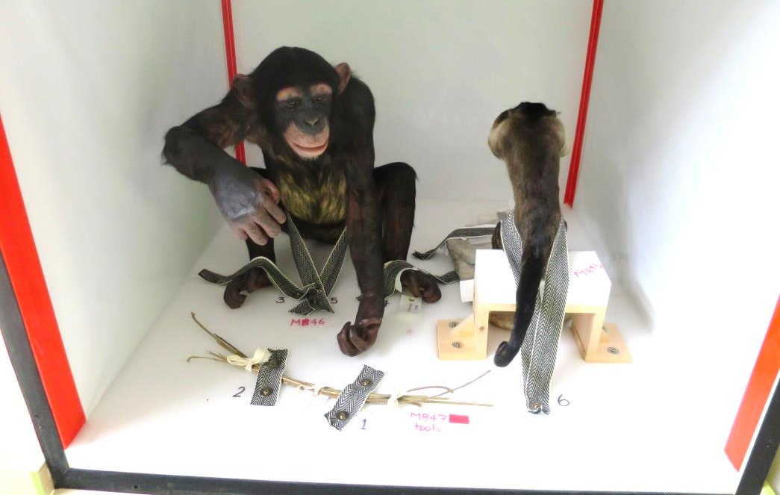

Plan of crate interior
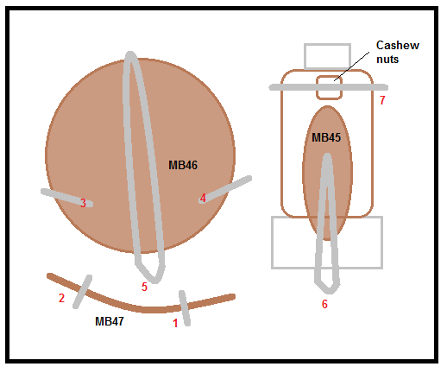
Unpacking
1. MB47 Chimpanzee tools x8
- Remove screws 1 and 2 to release straps
- Remove cotton tape and lift out from the crate

2. MB46 Chimpanzee
- Remove screws 3, 4 and 5 to release straps
- Support body and lift up and out from the crate

3. MB45 Brown capuchin + cashew nuts
- Note: Cashew nuts are packed in bag and secured by a strap
- Remove screws 6 and 7 to release straps
- Hold the edges of the groundwork and lift up and out of the crate

Make sure that all packing materials (screws, washers, straps etc.) stay inside the crate. Secure the crate using the bolts provided.

Packing
1. MB45 Brown capuchin + cashew nuts
- Hold the edges of the groundwork and lift into the crate. The specimen should be up against the support block at the rear and the front
- Place the loose cashew nuts back into the bag so that they will be held in place by the strap
- Position strap 6 and place a piece of Tyvek under the strap, replace screws 6 and 7

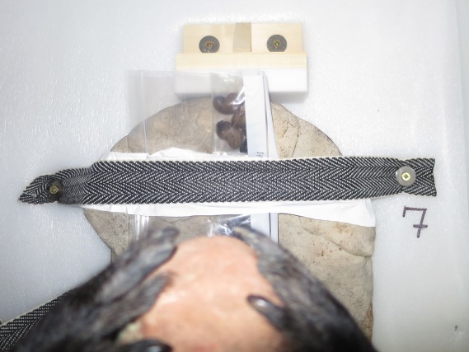
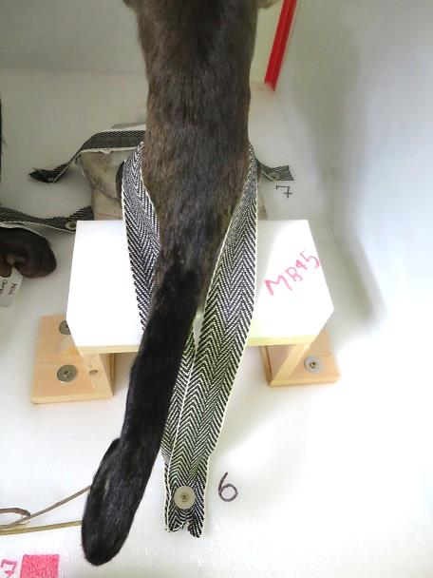

2. MB46 Chimpanzee
- Support the body and lift into the crate. Place a piece of Tyvek under strap 5 and position around the mid body, replace screw 5
- Place a piece of Tyvek under straps 3 and 4 and replace screws 3 and 4
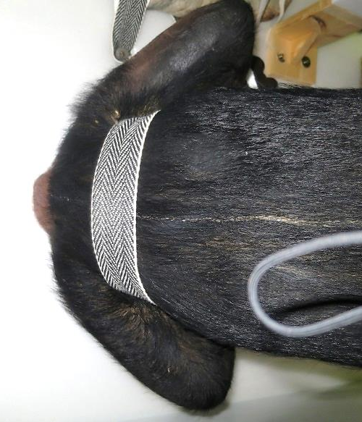

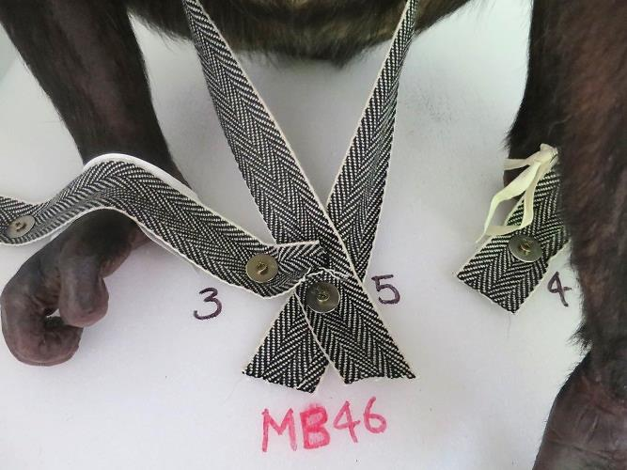

3. MB47 Chimpanzee tools x8
- Tie cotton tape around tools
- Position straps and replace screws 1 and 2

Once all specimens are packed check that they are all secured in position before replacing the crate door using the bolts provided.

ADDITIONAL NOTES AND CHANGES TO TRACK
Please include DATE and INITIALS.

END OF CRATE M23 NOTES

