Wildlife Photographer of the Year
20 Jan-6 May 2024
Visual Guide

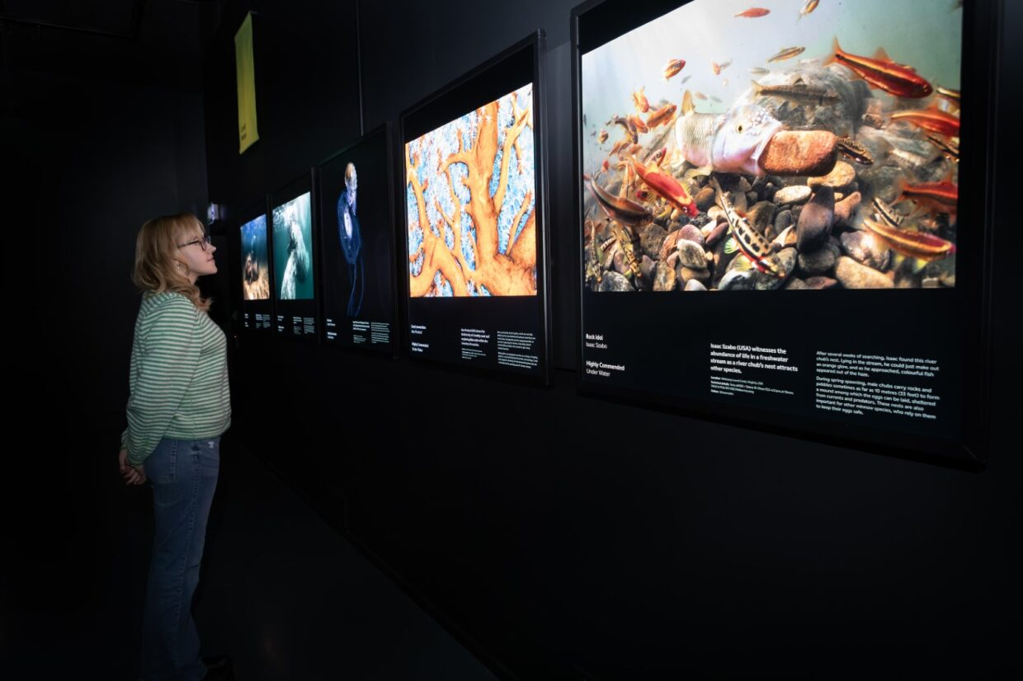

National Museum of Scotland
Chambers Street
Edinburgh
EH1 1JF

This visual guide is designed to support a visit to the exhibition Wildlife Photographer of the Year at the National Museum of Scotland.

Contents
Visiting the National Museum of Scotland 3
Tickets 3
Visiting the exhibition 5
General information 5
Notes on the exhibition 5
Relaxed Viewings of Wildlife Photographer of the Year 5
Getting to the exhibition 6
Toilets 6
Exhibition Sensory Map 7
A visual walk through the exhibition 8
Exhibition exit and shop 12
Contact us 13

Visiting the National Museum of Scotland

There are two entrances to the National Museum of Scotland.
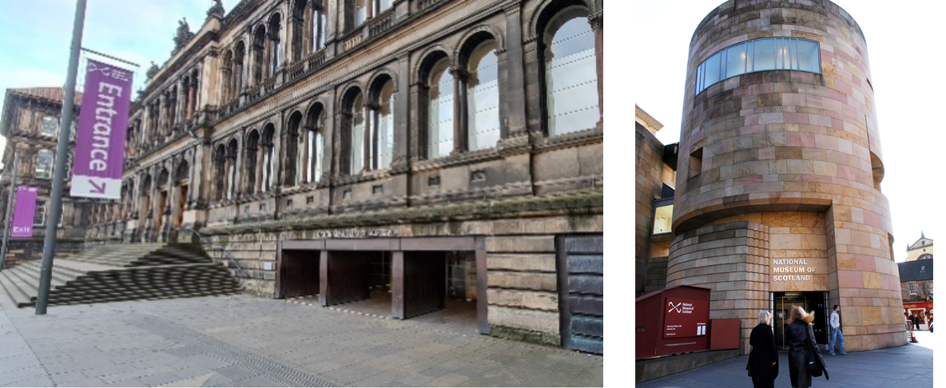
The Main Entrance The Tower Entrance
The Tower Entrance is usually quieter and offers step-free access to the museum.
Please visit our ‘Plan Your Visit’ webpage: https://www.nms.ac.uk/national-museum-of-scotland/plan-your-visit/ for more information about getting to the museum, facilities, and accessible parking. You can also download a map of the museum.
Guide dogs and assistance animals are welcome in all areas of the museum.
General visual stories are available to support your visit:
Main entrance visual story
Tower Entrance visual story
To find out more about accessibility at the museum please visit: https://www.nms.ac.uk/national-museum-of-scotland/plan-your-visit/accessibility/

Tickets
A general visit to the museum is free and no booking is required. However, to visit the Wildlife Photographer of the Year exhibition you will have to buy a ticket. Tickets can be purchased online (click to visit the booking page) or purchased at either the Main Entrance Information Desk on level 0 or outside the exhibition on Level 3 subject to availability. Tickets are cheaper when purchased in advance of your visit (up to 24 hours before visiting). We recommend booking in advance to avoid disappointment.
If you need any help with booking tickets, please call 0300 123 6789 (10:00-17:00).
To find out about ticket pricing please visit our website: https://www.nms.ac.uk/exhibitions-events/exhibitions/national-museum-of-scotland/wildlife-photographer-of-the-year/
When you arrive at the museum, there are information desks at both entrances. If you would like to pick up a map or if you have any questions, our Visitor Experience staff can help you.
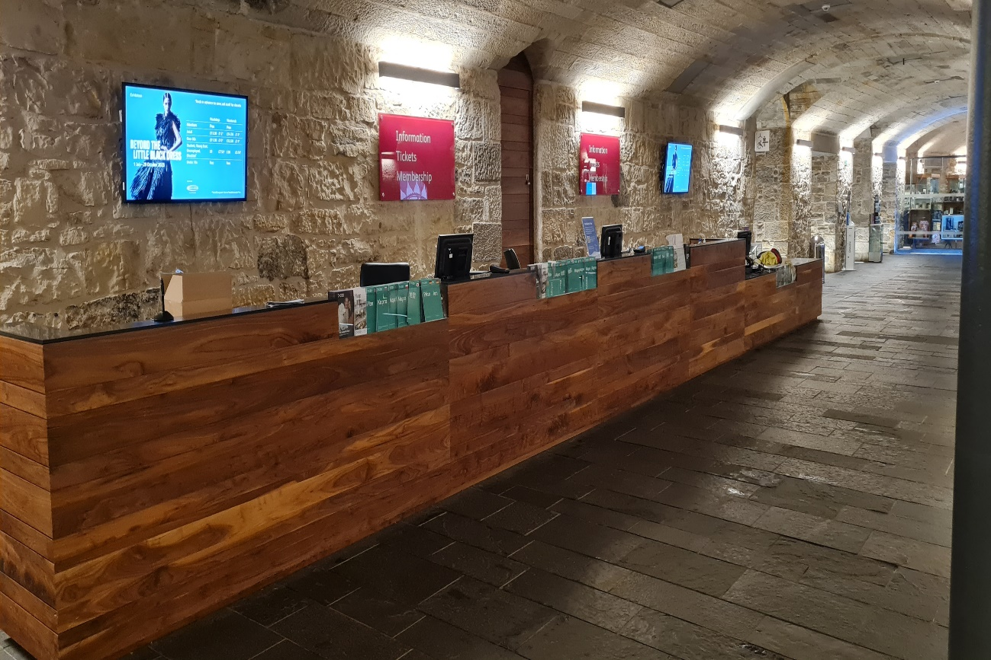
Our visitor experience staff wear purple shirts and lanyards and are available throughout the museum.
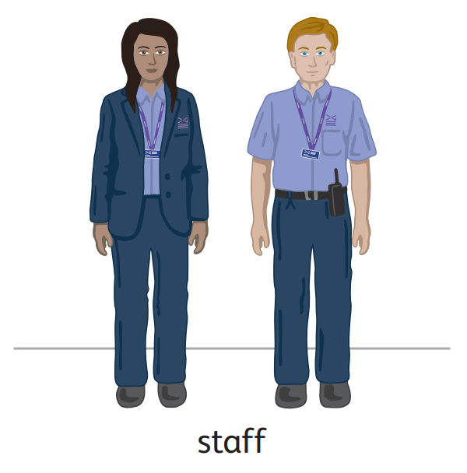

A limited number of sensory maps of the museum and sensory backpacks are available to borrow for free from the information desks.

Visiting the exhibition

General information
In this world-renowned exhibition, on loan from the Natural History Museum in London, see exceptional images which capture fascinating animal behaviour, spectacular species and the breathtaking diversity of the natural world.
Wildlife Photographer of the Year is the most prestigious photography event of its kind, providing a global platform that showcases some of the best photography talent from around the world for nearly 60 years.

This exhibition contains images that some visitors may find upsetting. Please contact info@nms.ac.uk for more information.

Notes on the exhibition
- Personal photography is encouraged but flash is not allowed. Filming is permitted for personal, not-commercial use, on a personal device.
- No eating or drinking in the exhibition.
- There are wooden benches available in the exhibition. Portable foldable stools are also available at the exhibition entrance.
- Large print guides are available in a holder through the entrance door to the right.
- Light levels are low in the exhibition. The photographs are backlit.
- The floors are dark grey and reflect light in some places.
- ‘Explorer Camera Challenge’ trails are available to use within the exhibition or via a QR code.
The exhibition has a 38 minute sound installation featuring music and the sounds of wind and water. It plays constantly but will be turned off for Relaxed Viewings.

Relaxed Viewings of Wildlife Photographer of the Year
Relaxed viewings of Wildlife Photographer of the Year will be held at the following dates/times:
Sunday 4 February 2024, 10:00–12:00
Sunday 3 March 2024, 10:00–12:00
Tuesday 12 March 2024, 17:30-19:00 (please note this is an after-hours viewing)
Tuesday 9 April 2024, 10:00-12:00

During these times the following adaptations to the exhibition will be made:
- Visitor numbers will be reduced
- Video sounds will be turned off
- The exhibition sound installation will be turned off

Getting to the exhibition
Wildlife Photographer of the Year is in Special Exhibition Gallery 1 on Level 3 of the museum. Level 3 is accessible via a lift, an escalator, or stairs.
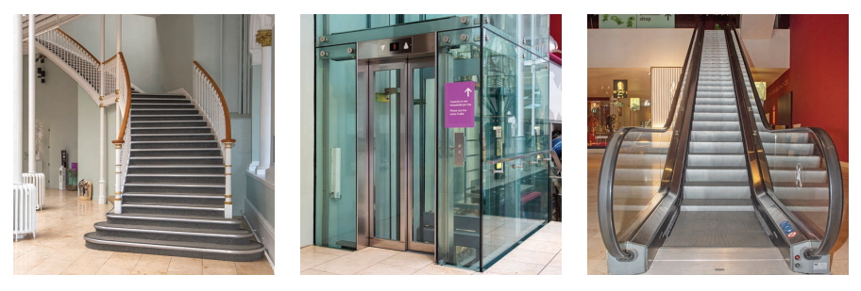
The entrance to the exhibition is on Level 3. Here you will be greeted by museum staff who will scan your ticket.
If you do not have a ticket, you can buy one at the exhibition ticket desk if available.
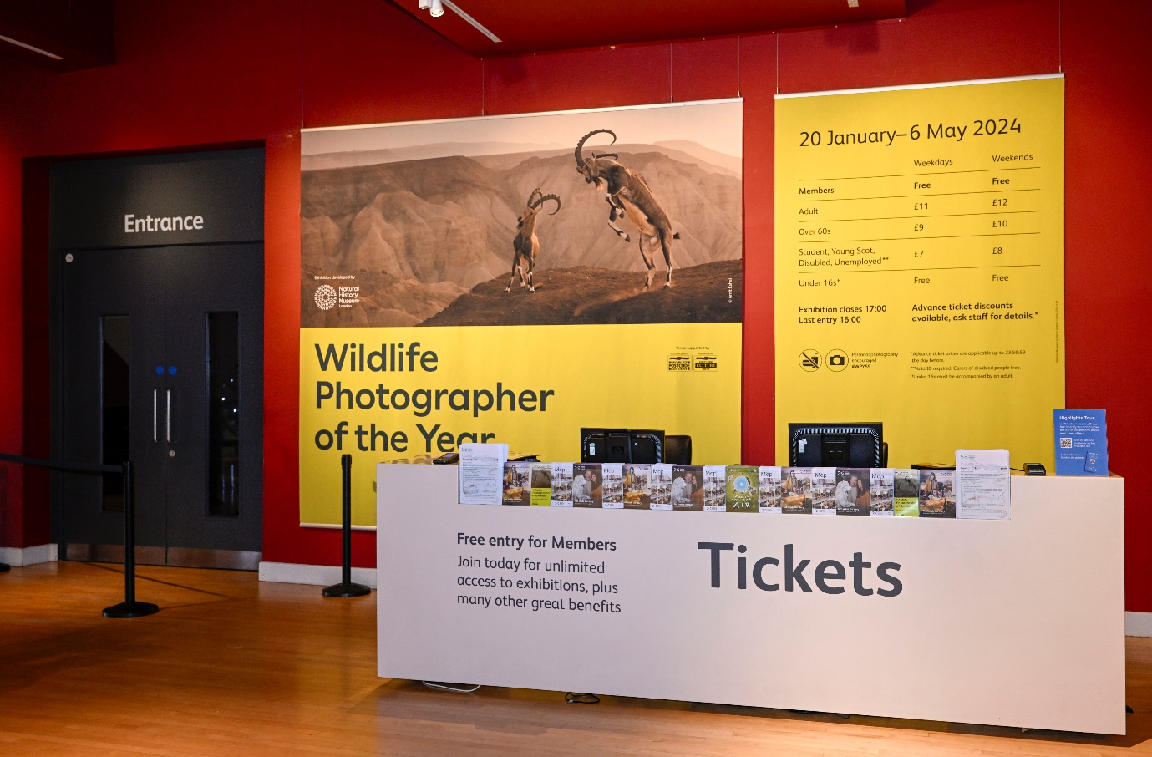

Toilets
The nearest toilets (including an accessible toilet) to the exhibition are on Level 3 through the Making and Creating gallery. There is a Changing Places (U) toilet available in the Level 0 Entrance Hall. It is opened with a RADAR key. One is available at the information desk next to the toilet entrance if you do not have your own. Toilets and accessible toilets are available on every level of the museum.

Exhibition Sensory Map
Printed copies of the Sensory Map are available to borrow from the Exhibition Information Desk on Level 3.
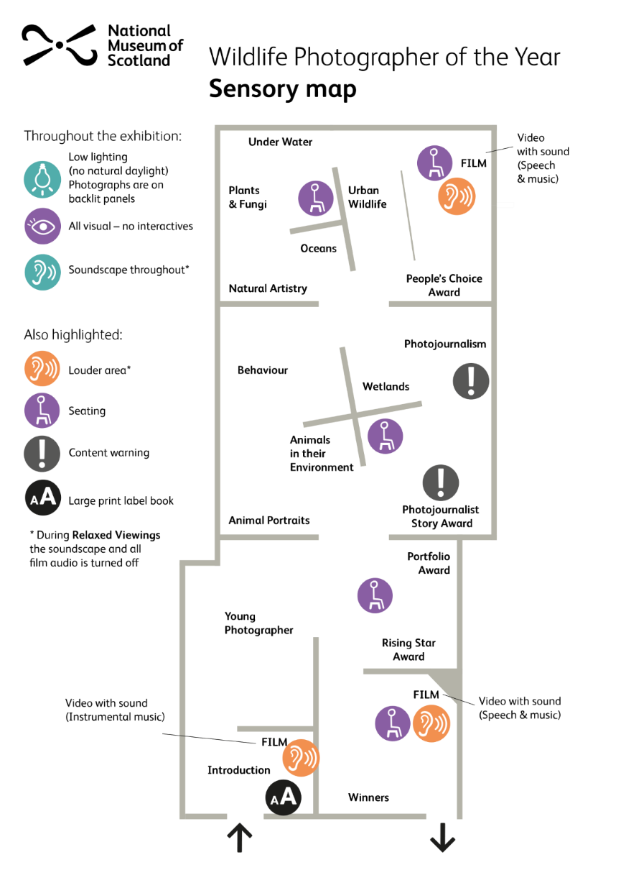

A visual walk through the exhibition
Introduction
The ‘Behind the Lens’ video is a one minute long looped video with a music soundtrack.
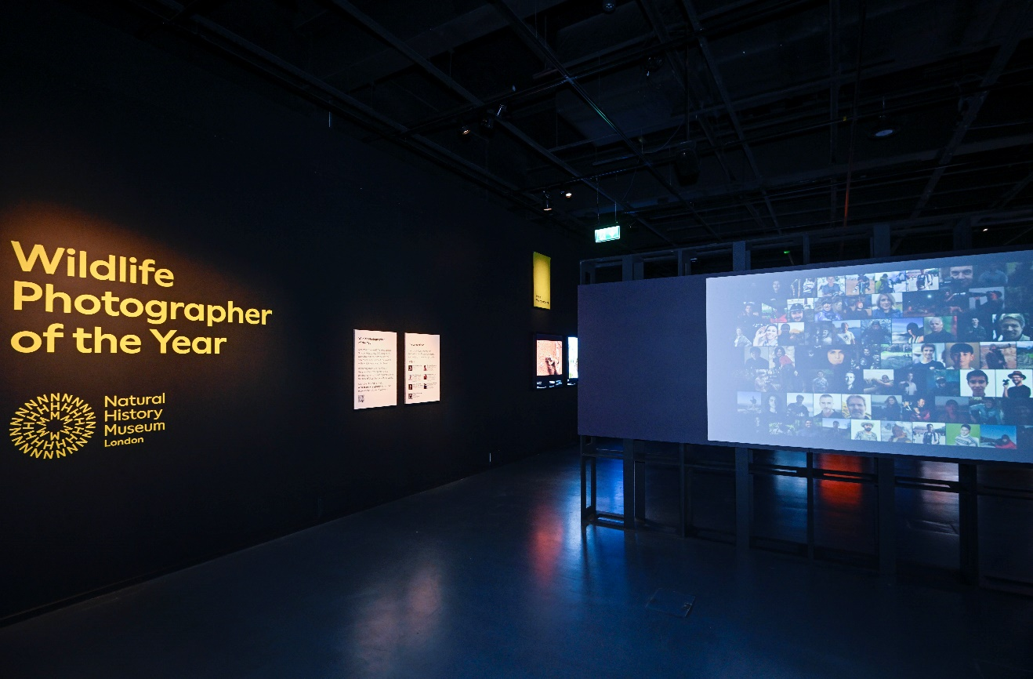
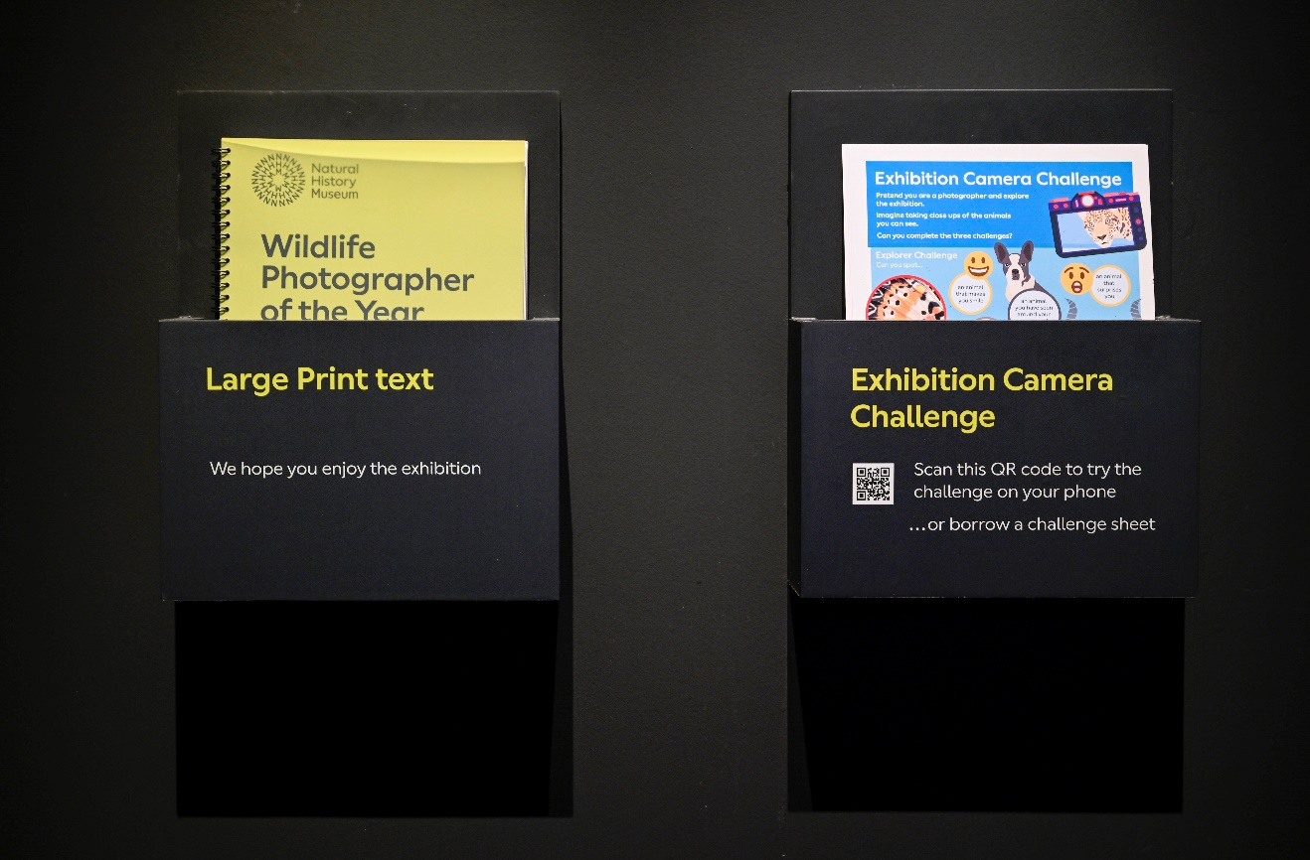
Large print labels and copies of the Exhibition Camera Challenge are available to borrow from stands on the right hand side of the entrance. Please return them to the stands by the exit when you have finished your visit.

Young Photographer
In this area, some sound can be heard from an audio-visual in another area.
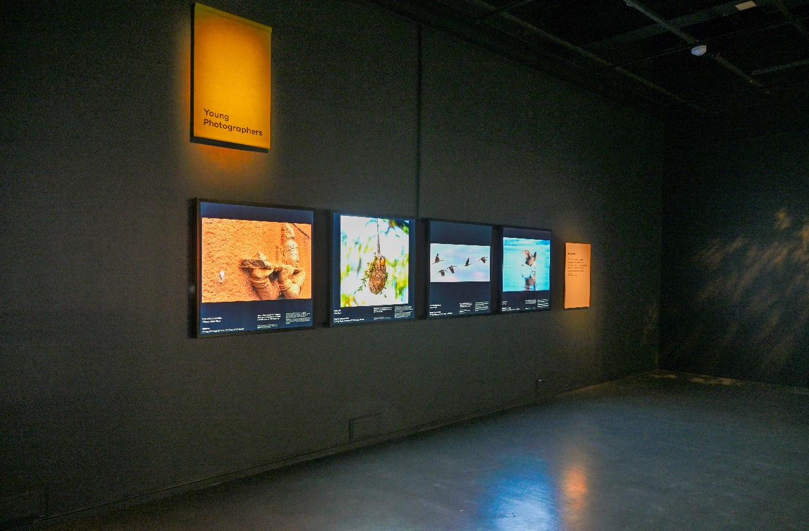
Portfolio Award
There is a wooden bench in this area.
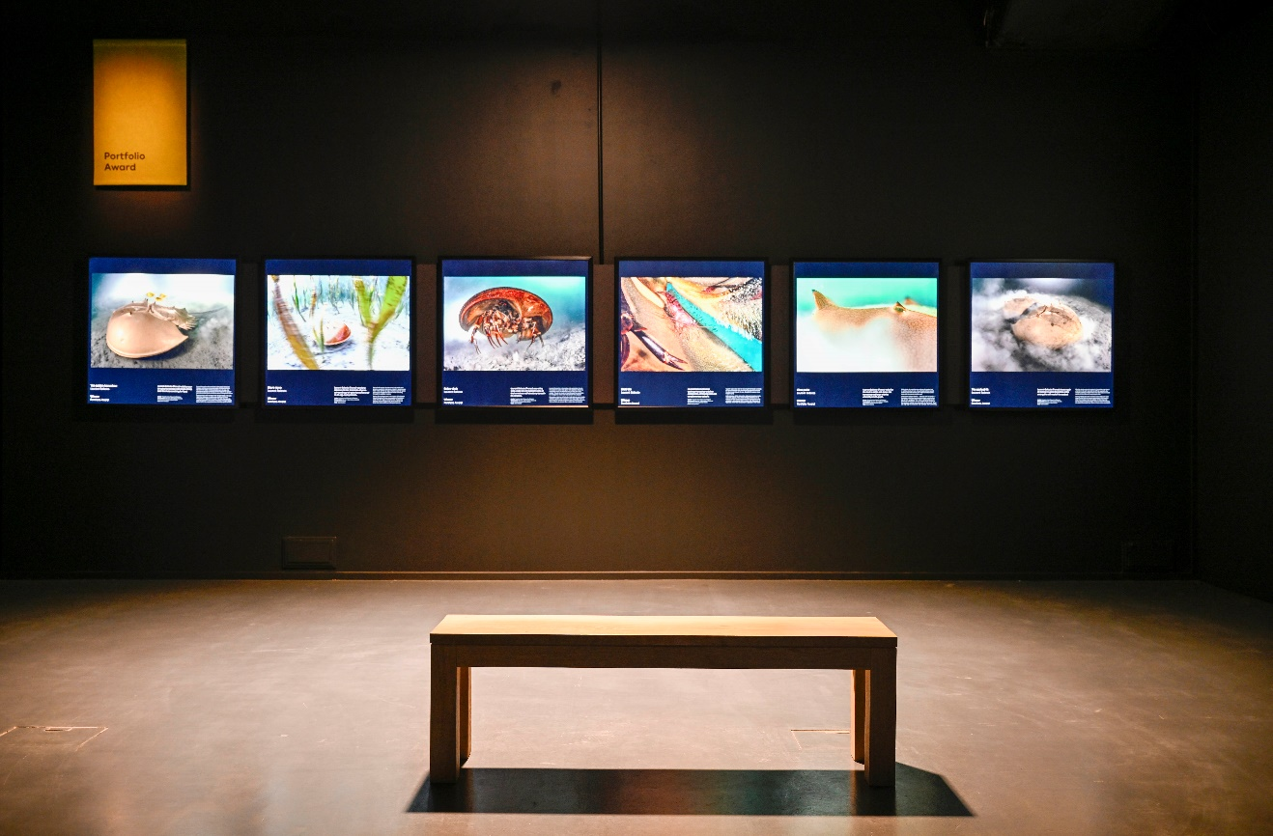

Animals in their Environment/Animal Behaviour
In this area, please be aware that some photographs are displayed behind you.
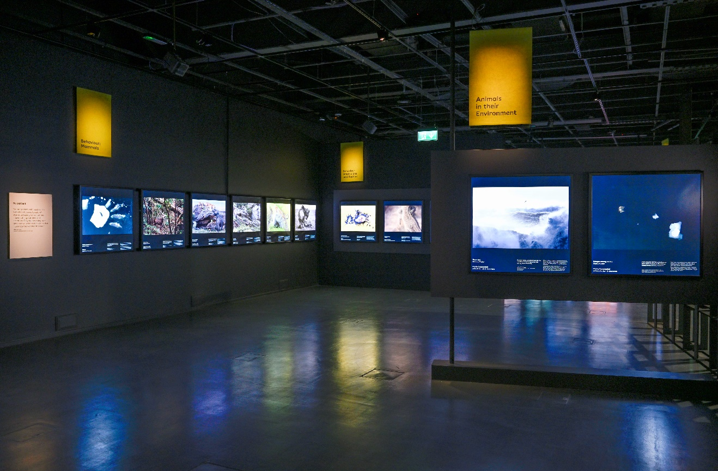
Film: The Impact of an Image
The film is 6 minutes long and plays on loop. It shares two stories and is subtitled. The film area has two wooden benches and is behind a gauze screen wall. You can avoid this area if you would prefer not to watch the film.
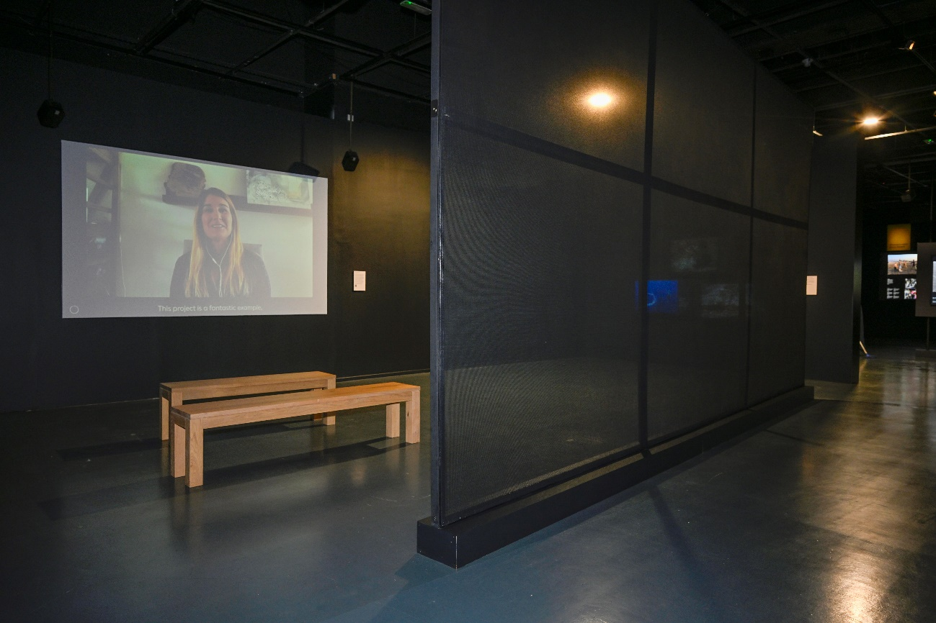
People’s Choice Awards
This area has three screens which show a rotating slideshow of photographs.
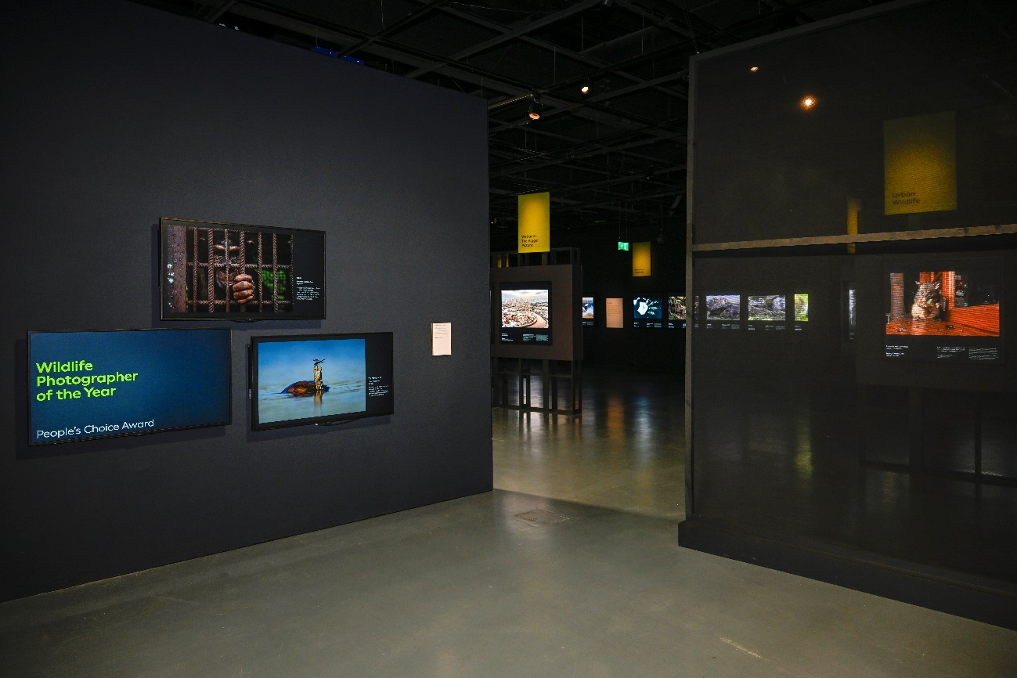

Photo journalism
This area has a content warning as it contains photographs some people may find upsetting.
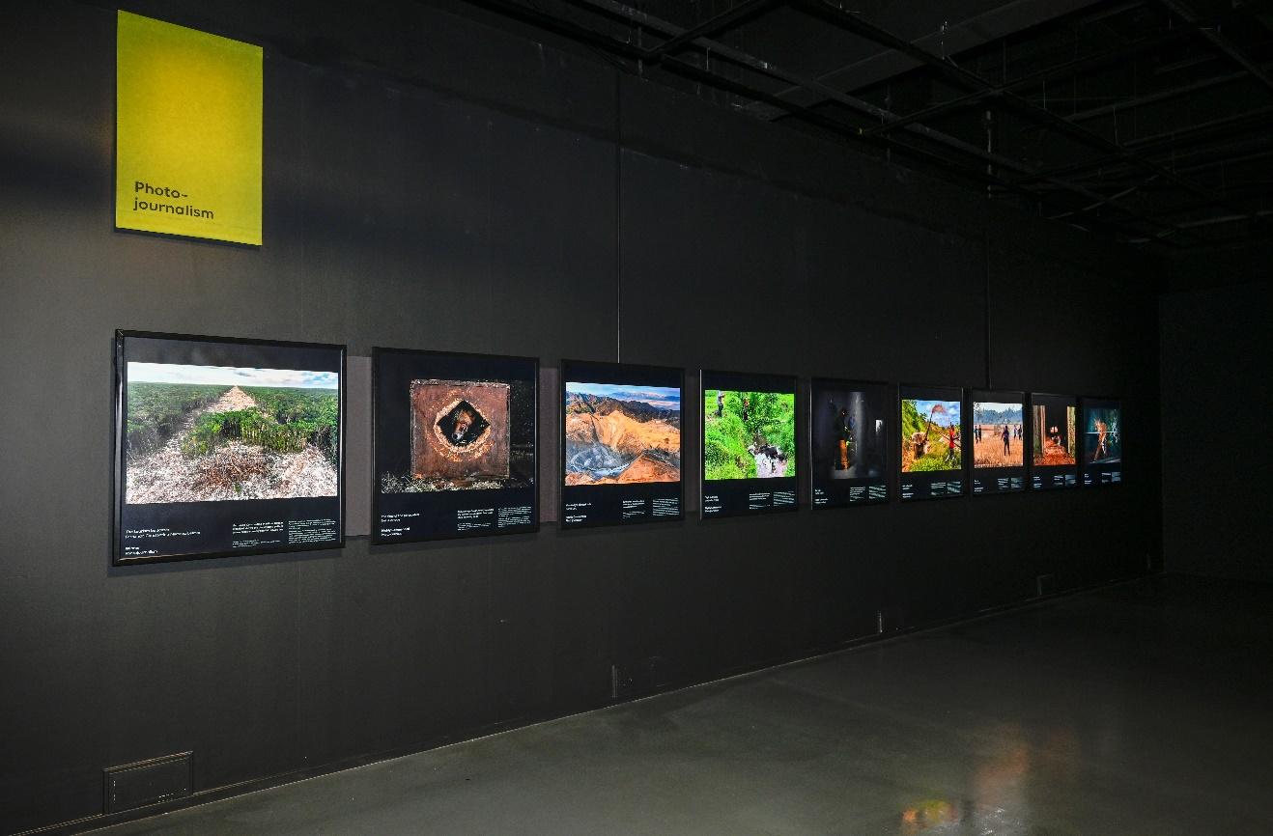
Film: Grand Title Winners
The film is 8 minutes long and plays on a loop. There are subtitles and a small white circle in the bottom left corner showing how far through the film it is.
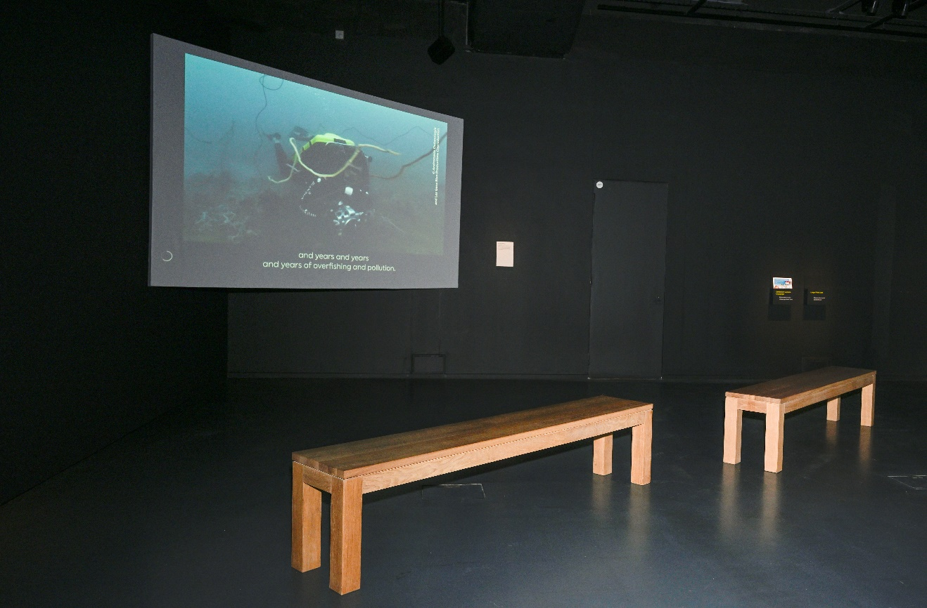

Exhibition exit and shop
You will exit the exhibition through this door.
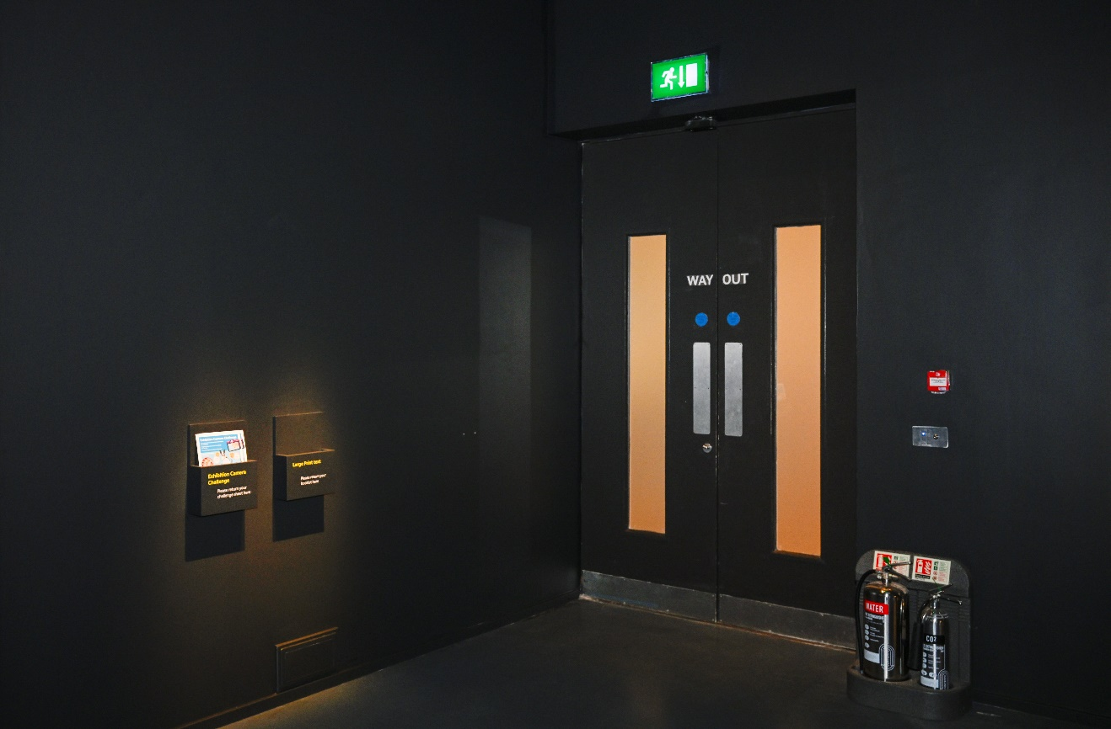
The Exhibition Shop is opposite the exit.
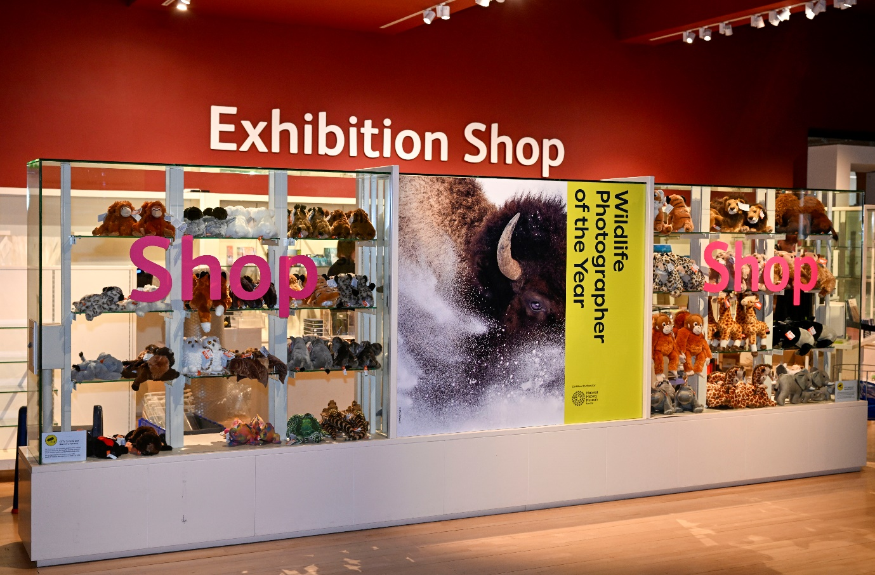
We hope you enjoy your visit.

Contact us
If you require any further information about the museum or the exhibition please use the following contact details:
Email: communities@nms.ac.uk
Call: 0300 123 6789 (Monday-Friday, 10:00-17:00)
Or visit our website www.nms.ac.uk

